* Fragments basically let you a group a list of children elements withouts adding extra nodes to the dom.
* <> </> this represent react fragment but you cant pass key if u using like this

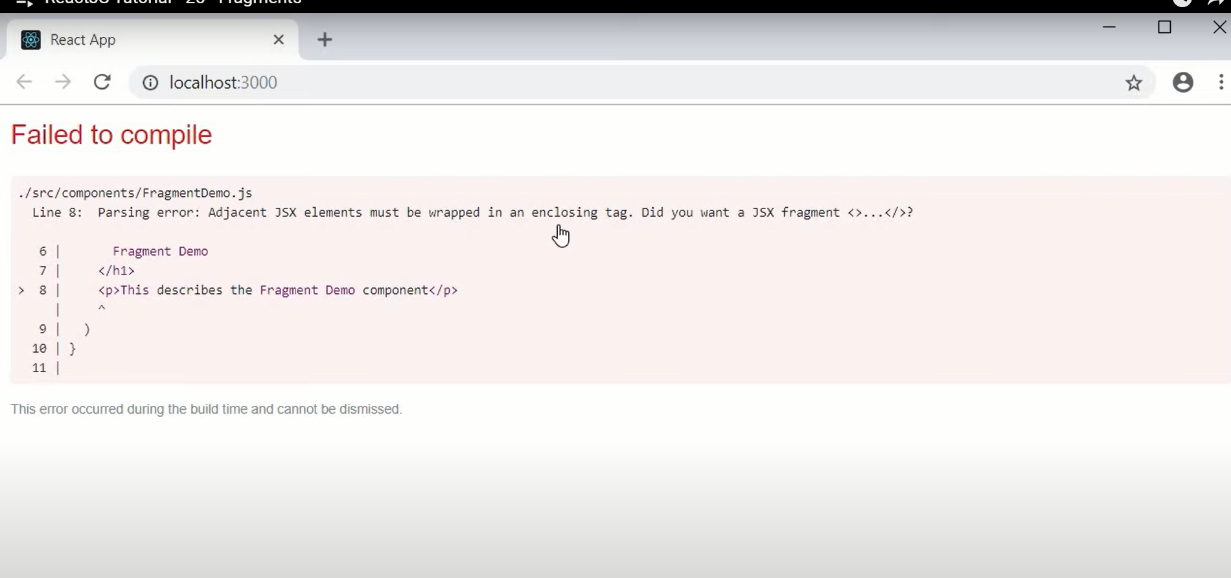

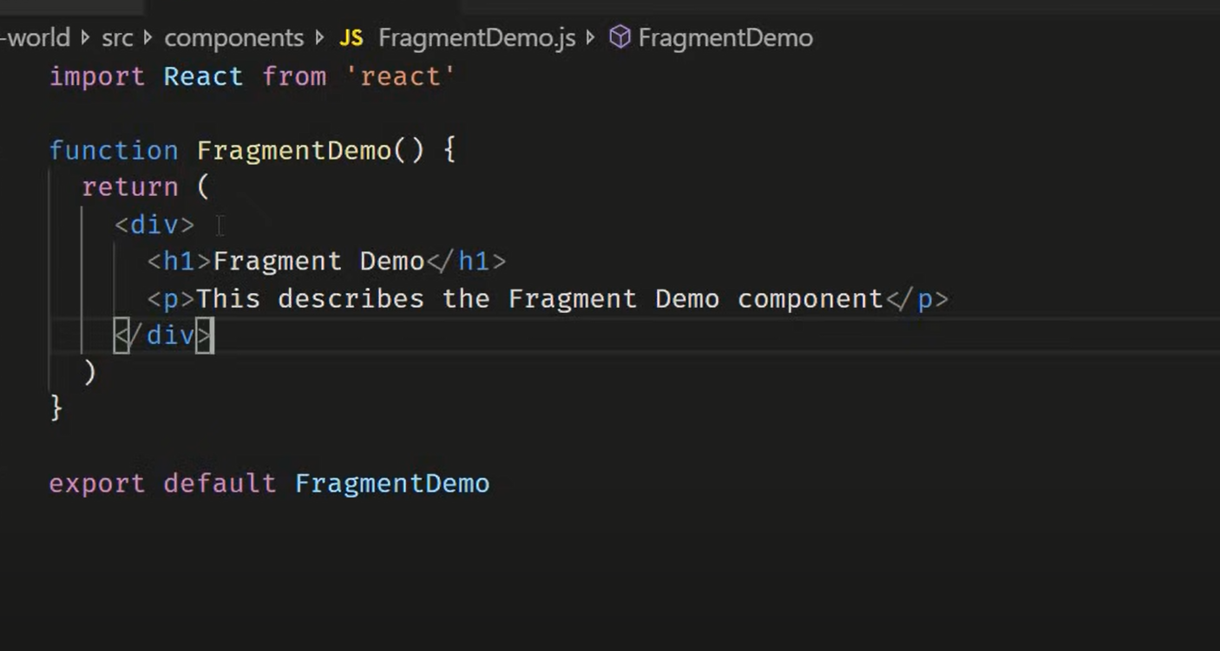

After adding div it is also adding extra div to dom :

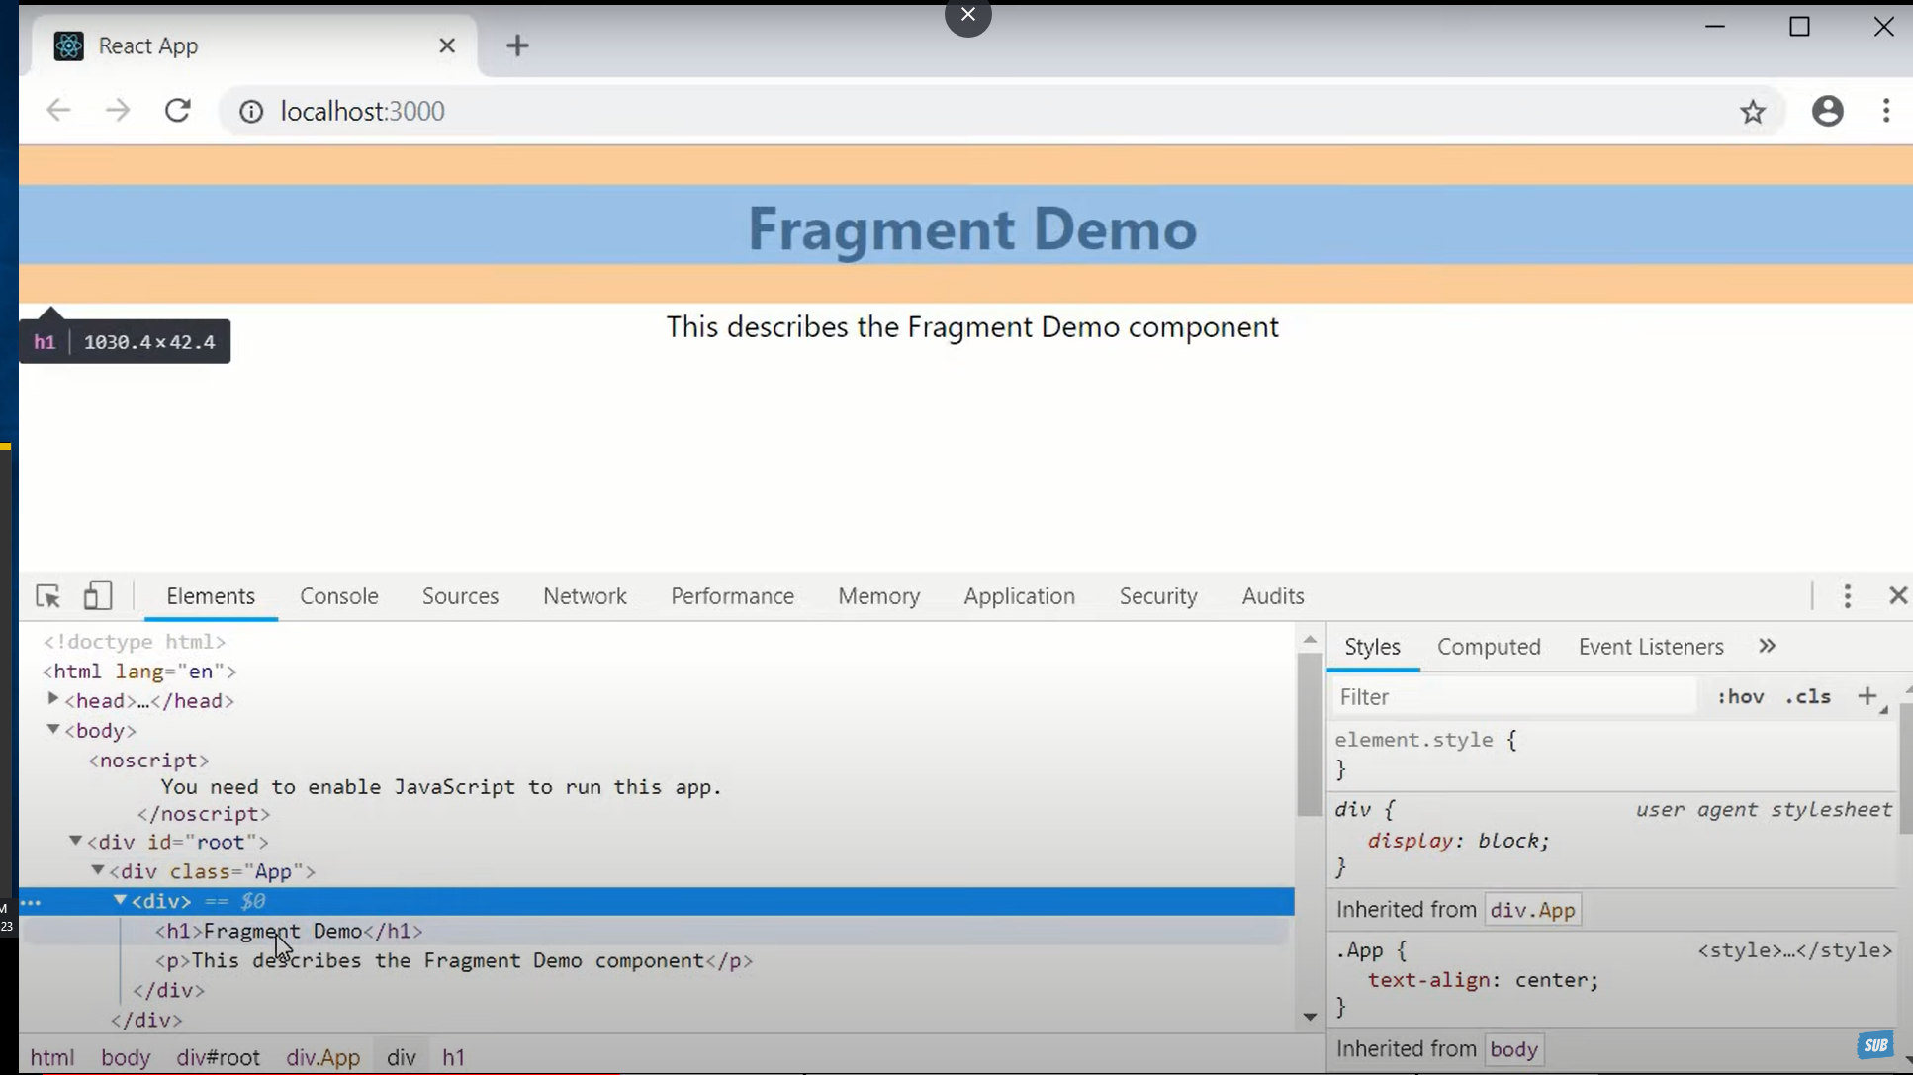

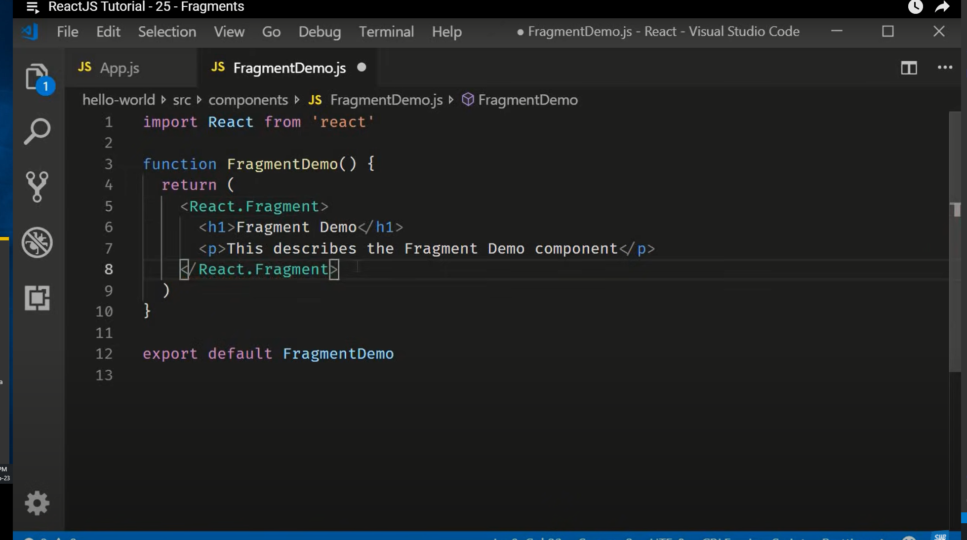

**2nd Example :**

**Created 2 component like table and column and try to call column component to table component:**

import React from 'react'

function Table() {

  return (

    <div>

      <table>

        <tbody>

            <tr>

                <columns></columns>

            </tr>

        </tbody>

      </table>

    </div>

  )

}

export default Table

import React from 'react'

function Column() {

  return (

    <div>

      <td>Name</td>

      <td>Subhishek</td>

    </div>

  )

}

export default Column

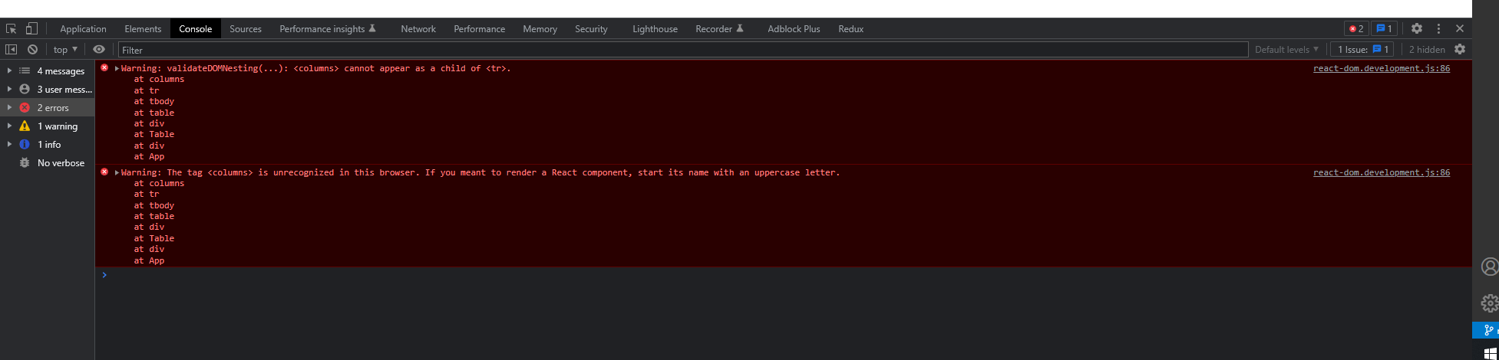

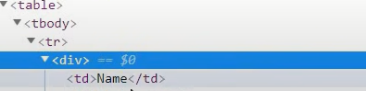

In Column component Replace div tag with React.Fragment :

import React from 'react'

function Column() {

  return (

    <React.Fragment>

      <td>Name</td>

      <td>Subhishek</td>

    </React.Fragment>

  )

}

export default Column

In React fragment we can also pass key :

